Database Report

# Task 1 – Write Database Requirements Report

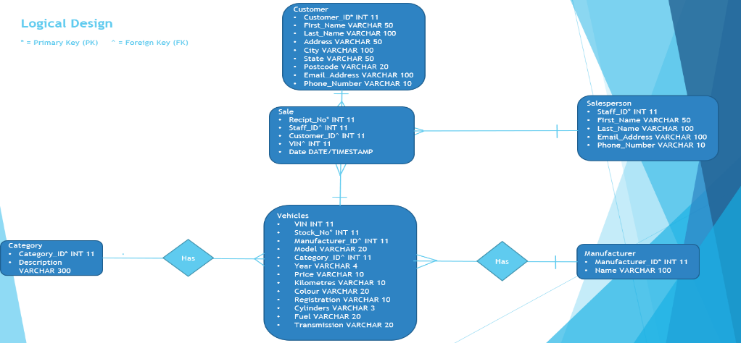This is the entity relationship diagram (ERD) with what the relationships are (one-to-many, many-to-many etc.).

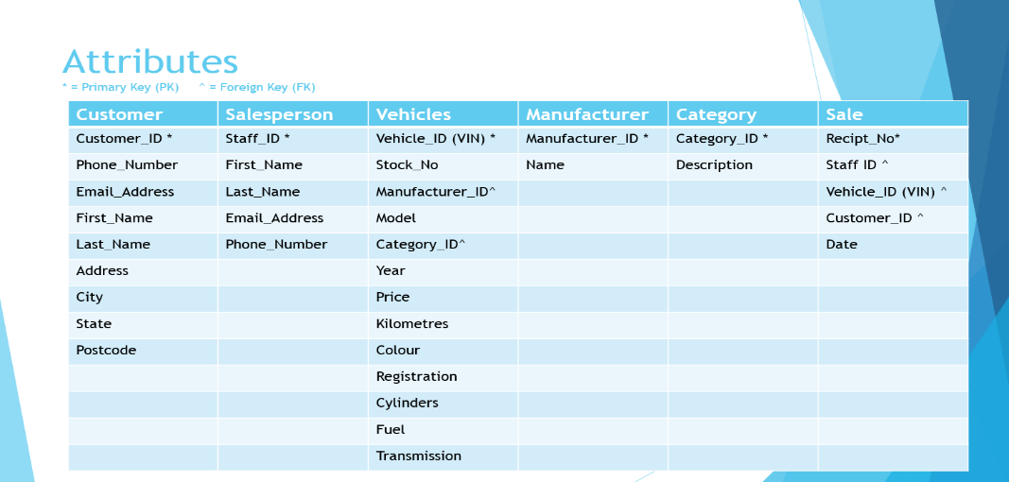This is the ERD in table format.

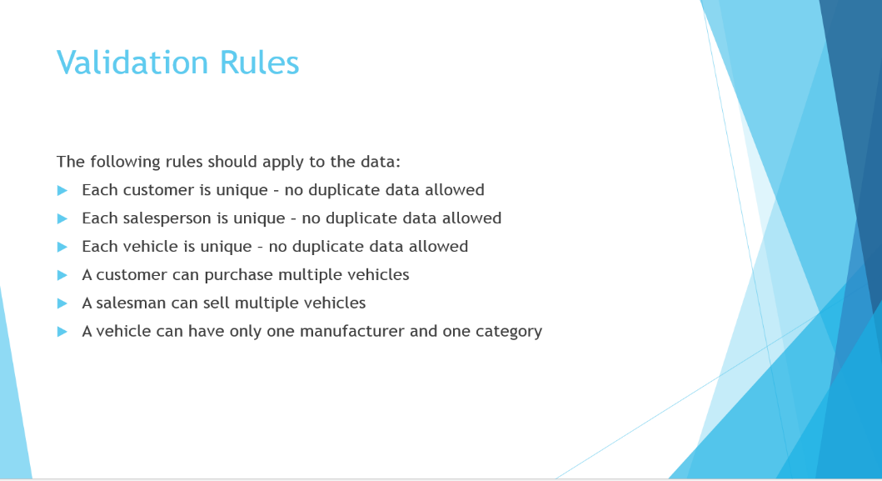These are the validation rules.

# Task 2 – Create Database

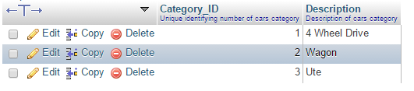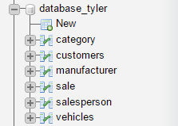

Category sample data

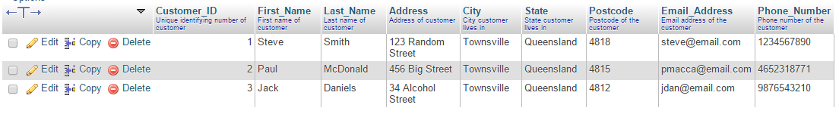

Customer sample data

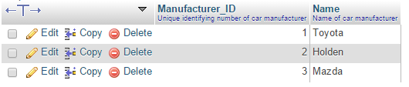Manufacturer sample data

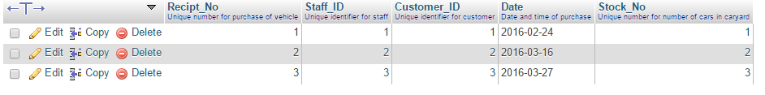Sale sample data

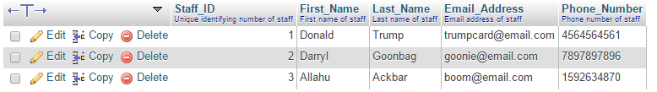Staff sample data

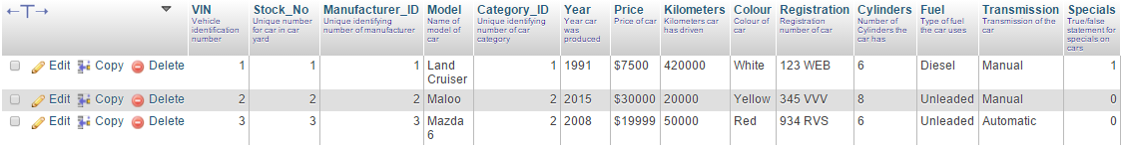Vehicle sample data

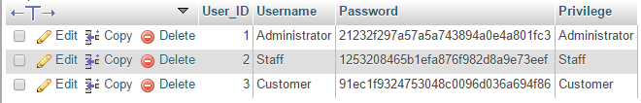Users sample data

# Task 3 – Design User Interface (Wireframe)

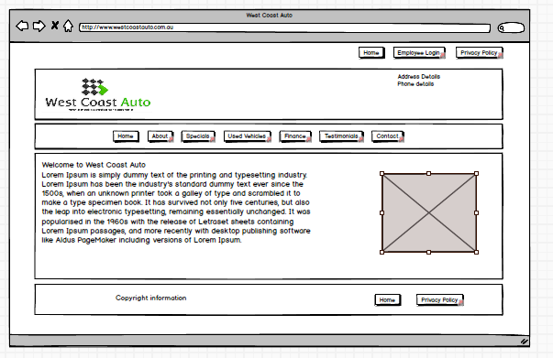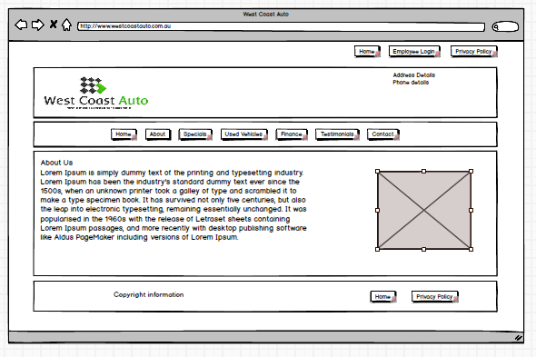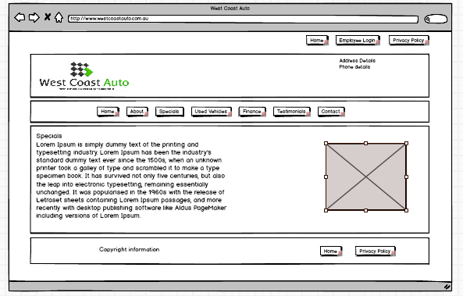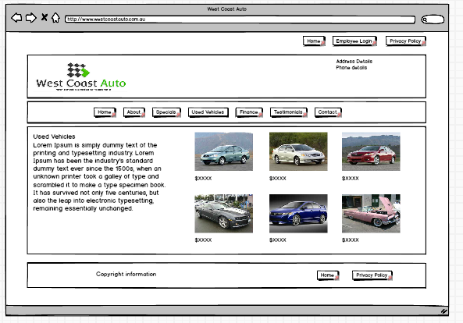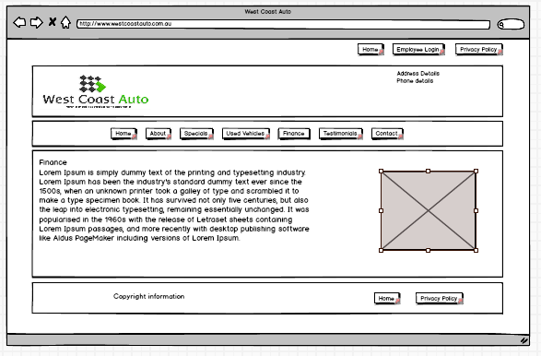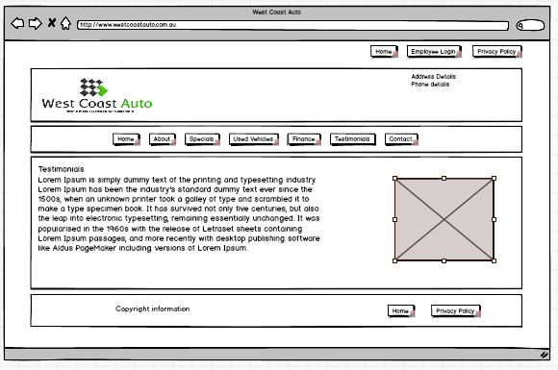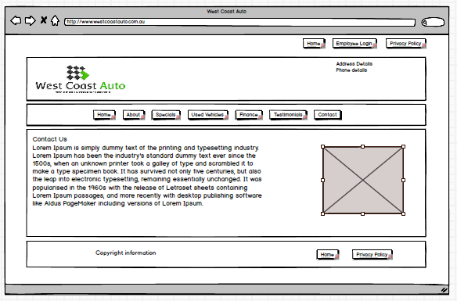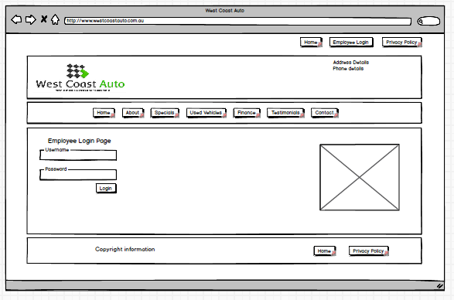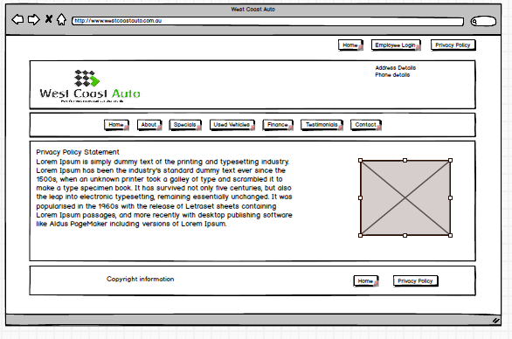

# Task 4 – Create Security Policy

There is a “*Users”* table that has been added to the database that allows and restricts users on what they can do to the database. Administrators have full access to the database, so they can read, write and delete information from the database, staff are restricted to;

* Adding vehicles, customers/clients
* Displaying client information and salesperson information.

Customers/clients are the most restricted users on the database, they can only view the list of vehicles that are available.

Passwords have been made secure by making them show up as MD5 in the database, which makes each character have a set of characters, which makes them more secure.

# Task 5 – Create Backup Procedure

A suitable backup schedule for the database would be to incrementally update it at the end of each day and to do a full back up every Sunday at close of business by an administrator level staff member.

The backup should be stored on either a disk drive (USB, HDD or SSD) in a safe or in a secure cloud service (Dropbox, Google Drive etc.) or preferably both. This can be done in PHPmyAdmin by exporting the database to a location in the disk drive, then to the cloud if need be. The backups should have a naming convention similar to *Database_Backup_(Date).*